**Name : Mubin Salim Sayyed**

**Project Partner : Abdul Kalam Sk. Salahuddin**

**Project Name : Art Gallery Management System**

**Class : TY BSC (Computer Science)**

**Roll No. : 217 & 216**

**Art Gallery Management System**

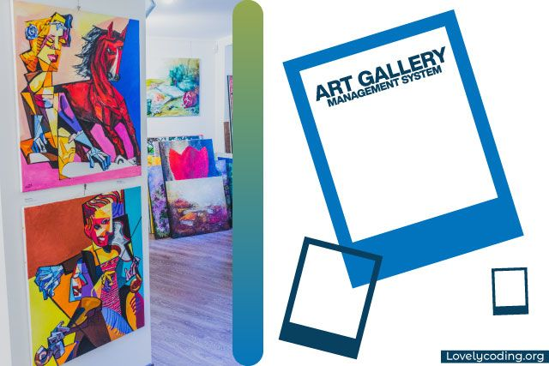

Art Gallery Management System

SYSTEM DESCRIPTION OF ART GALLERY MANAGEMENT SYSTEM

Are you looking for Art Gallery Management System project? We are here to help you. You can [contact us](https://www.lovelycoding.org/contact-lovelycoding/).

Art gallery management system is a website that allows buyers to purchase paintings, scriptures, models online. The purchase is just a click away, you don’t have to go to some old museums and buy from selected stuff.

This website will provide you with a wide range of choices. The registration in this website is free, unlike other sites. It provides various categories too, in buyers’ accordance.

It provides free home delivery to buyers. It allows users to create their own portfolios.

The main menu will contain five parts which are as follow:

Home

Artworks

Artist

About Us

Admin Login

User Login

User Sign Up

Now, we can see that nearly everything is very much possible to perform with a single click so this system will help you to computerize the system so that user and client can access the system online.

These are some key features of the system which is as follow:

To reduce the hectic of maintaining the record of inventories

To reduce the cumbersome job of maintaining several documents

It will eliminate the delays in the generation of reports that which item has sold to whom.

Searching will become more efficient and fast.

It will also provide assurance to the customer that they can buy the art they like there would be no pressure.

Overall it will reduce the cost and time of the customer.

You can also check these posts:

* [Online Shopping System](https://www.lovelycoding.org/online-shopping-system/)
* [Online Shopping Project](https://www.lovelycoding.org/online-shopping-project-in-php/)
* [College Management System](https://www.lovelycoding.org/college-management-system/)
* [Book Store Management System](https://www.lovelycoding.org/book-store-management-system/)
* [Food Ordering System](https://www.lovelycoding.org/food-ordering-system/)

EXISTING SYSTEM DESCRIPTION OF ART GALLERY MANAGEMENT SYSTEM :

In this section, we will discuss the existing system and some of their drawbacks which force us to plan this whole idea of developing online Art gallery management system.

Let us takes the few examples

Suppose we went to the museum or art gallery there we found something which we really want to purchase so for that we need to contact to the manager and talk to him to get aware about the procedure of purchasing,

but at last moment we come to know that someone has already booked that painting or art there we feel helpless because that painting was on sale for three days and you were not able to purchase it just because of lack of time and the distance you need to cover from your home to art gallery.

This thing generally happens in art gallery sometimes we are out of cash and want to pay through credit card but this mode of payment is not allowed in some art galleries.

DRAWBACKS  OF ART GALLERY MANAGEMENT SYSTEM :

This process is so much time consuming

There is a threat to the record of the customer so it might be the case that one painting can be sold twice.

There is no proper way of getting new paintings record customers need to search by their own.

It might be the case that manager can take a commission as well as extra charges for transport the paintings to the customer.

So, above this is the whole process of getting an art from the Art gallery by our system we can make it a little bit more simple and fast process of automating it.

We can automate this process by creating the application which will allow you to use these things in a fully functional way and the application will include the following entities (an entity is a real-world object).

The automated application help in following way:

The customer can register himself directly on the application for any fare or sale in galleries and generate customer id.

If the customer is not aware of policies then admin will make him contact with this application and help him to complete the process.

Admin will maintain the record and atomicity by using the proper table to save records so that no one can access it and one person purchase only one statue.

Customer need not bother about his/her orders and without moving from his place or making so many phone calls he can get the painting.

No need of worrying about transportation to get paintings at your place.

The customer can check new paintings which have been uploaded by the Admin on the application.

The whole process of getting work done will become faster than the conventional way of getting insurance.

Let us look the different aspects which we have designed to make the website work properly.

HOME OF ART GALLERY MANAGEMENT

SYSTEM :

The art gallery is a reference point for Artists, collectors and for the different players of the art world.

ARTWORKS OF ART GALLERY MANAGEMENT

SYSTEM :

When it comes to selling your art, the more information that you provide in your artwork description the better! After all, this is where your customer will turn to learn more about your piece.

The best artwork descriptions on Artfinder comprise two sections: one detailing the **inspiration behind the piece** and another presenting **the bare facts**.

The inspirational bit -

This component of the description will need to refer directly to the artwork at hand. There's no perfect formula for this, however it does need to be engaging! Remember that it should reflect you and your personality, as well as your enthusiasm for your work.

ARTIST OF ART GALLERY MANAGEMENT

SYSTEM :

Promoting art has become an industry standard as well as an absolute necessity for artists in the part world today. In order to gain recognition and connect with your audience, you actually need to reach out to them and point them towards your work. While there are a number of documents that an artist needs to have, one of the most important and effective ones is a carefully crafted artist profile that describes your work as well as your artistic philosophy.

An artist profile is meant to tell the people who discuss and follow the art world about you and the art you make. It lets you engage tastemakers and, consequently, get them to bring your art to the attention of galleries, art institutions and potential buyers. Done correctly, an artist profile can set both you and your art apart from the crowd. It can tell people about what makes your work interesting and relevant. It can also describe a distinctive approach, highlight the use of unusual materials or reveal the compelling story that your art tells.

But, most importantly, an artist profile is simply a way of putting you and your pieces on the art world radar. To do that, you need more than just a good story—you need to be able to tell that story in an effective, engaging and concise manner. Following a few simple rules can make your artist profile a powerful aid in putting your art in front of potential buyers.

USER LOGIN AND SIGN UP OF ART GALLERY MANAGEMENT SYSTEM :

This option of the website will help the user to get a login and create his profile so that he can access new paintings and check the notifications if there is any new notification regarding new sculpture or Art so that he can bid for that or directly purchase that according to the procedure which has followed by galleries.

In this part, user can also upload his data related to its personal information such as name, sex, age and his interest related to paintings which is one of the important parts.

User login consists of two modules:

You can review the things and rate them according to that you can also purchase the things.

The user can also request to admin to keep his art in the exhibition for sale so if anyone finds paintings interesting then he/she can contact you.

PAYMENT MODE OF ART GALLERY MANAGEMENT SYSTEM :

This section of the module can explain how to buy a piece of art from our gallery,so that user can buy it easily.

In our website, we have designed it in such a way that user want to buy a painting. User would directly select the painting and user will get the details of the paintings and down there will get the option of Buy for buying the painting.

Then User will go to Make Payment page for buying the painting user needs to fill the details for making payment. If the payment done successfully The Piece of art means your painting will be delivered to your home safely.

ABOUT US OF ART GALLERY MANAGEMENT

SYSTEM :

This feature will provide the information about the website and the developers so that if you want to get a new design or any kind of change and suggestion you can come up to us.

CONTACT US OF ART GALLERY MANAGEMENT

SYSTEM :

In this section, we have provided the contact number and proper address so that client and user reach to us and mentioned their problems to solve it.

Now, let us discuss the ER-Diagram of the system but before that, we need to explain why we need ER-diagram why ER-diagram is so useful while developing and designing the system.

An entity relationship model also called an entity-relationship (ER) diagram, is a graphical representation of entities and their relationships to each other, typically used in computing regarding the organization of data within databases or information systems.

It consists of following fields such as:

An entity which is represented by rectangle it is a real-world object used to represent the user admin and other real objects.

ATTRIBUTES OF ART GALLERY MANAGEMENT

SYSTEM :

Every entity has their attributes such has every car has their specifications. Oval shape represents it.

In ER-diagrams diagonal is used to represent the relationship of the between the entities.

Here we will see the ER-diagram and its attributes:

Let us discuss the entities one by on with their respective attributes.

Artworks:

Artworks will contain al the attributes of an art.

Id :

It is the primary key of the Artworks. It will contain all the id no’s of the arts.

Artwork_work :

It will contain all the names of the paintings which is there in our art gallery

Artist_name:

It will contain all the names of the Artist which has painted the following arts.

Description :

It will contain all the details of the paintings, will describe the painting.

Amount :

It will contain the amount / the price of the painting that of which rate the painting should be sold.

User :

uid :

It contains the Id of the user who have signed up in the sign up page

user :

It contains the name of the user who have signed up in the sign up page

Pass :

It contains the password of the user who have signed up in the sign up page

Email :

It contains the email of the user who have signed up in the sign up page

Payment :

Pid :

It contains the payment id of the customer who will make payment for buying the art.

Full_name :

It contains the Name of the customer who will make payment for buying the art.

Address :

It contains the Address of the customer who will make payment for buying the art.

Mobno :

It contains the Mobile no. of the customer who will make payment for buying the art.

Card_no :

It contains the Acrd no. of the customer who will make payment for buying the art.

FEASIBILITY OF ART GALLERY MANAGEMENT

SYSTEM :

Feasibility is a test of system proposal according to its workability impact on the organization, ability to meet user needs & effective use of resources.Three key considerations are involved in the feasibility analysis are as under

OPERATIONAL FEASIBILITY OF ART GALLERY MANAGEMENT SYSTEM :

to find out whether the system will be functional after its development and installation?

The outcomes of the operational feasibility are :

A system to be developed is a critical need for business purpose only.

TECHNICAL FEASIBILITY OF ART GALLERY MANAGEMENT SYSTEM :

to examine out whether the current technology is sufficient for the development of the system.

An estimate is made of whether the identified user needs may be satisfied using current software and hardware technologies.

The outcomes of the technical feasibility are :

Existing technology supports the system completely

ECONOMIC FEASIBILITY OF ART GALLERY MANAGEMENT SYSTEM :

This analysis is most frequently used method for comparing the cost with benefit or income that is expected from the developed system.

USER INTERFACE OF ART GALLERY MANAGEMENT SYSTEM :

This is one of the main tasks of the developer to design such an interface that user can use it easily in one word it should be user friendly and for this you should have better understanding of the audience which going to use this application, initially we need to locate the targeting people that what kind of application do they need.

After getting all this information we should start to design the application.

SYSTEM REQUIREMENTS OF ART GALLERY MANAGEMENT SYSTEM :

The user should have the appropriate version of windows.

The system should have up to 1 GB ram minimum requirement for the application.

The application should be installed on the system.

Internet Connectivity is must for this purpose

Cpu with a speed of 1.3Ghz is a good choice for normal usage.

|  |
| --- |
|  |

FUTURE SCOPE :

Enhancement of our proposed system after successfully implementing the it can be added in the system that displays the Art and his details when the User want to purchased any art then he can car and ship this art on billing address.When the developed system runs successfully.

Online User register facility could be brought on Web that would enable the User to register and can see the detail in the system itself by entering his login id No.

There should be some page like Payment Gateway, Cash on delivery can give the better option for Purchasing an Art.

If user want to send Art detail to his friend then there is option to mail Art detail to friend is necessary in Art page.

Each of these tasks serves describes the problem so that an overall approach or solution may be synthesized.

❖ **IDENTIFICATION AND AUTHORIZATION**

The authorization mechanism prepares the user profile for a user and indicates the portion of the database accessible to that user and mode of the access allowed. The enforcement of the security policies in the database system requires that the system knows the identity of the user making the requests. This in turn requires that before making any request, the user has to identify herself or himself to the system and the authenticate identification to confirm that the user is in fact the correct person.

❖ **AUTHENTICATION**

The simplest and most common authentication scheme used is a password to authenticate the user. The user enters the user name or number and then authenticates her /him by the password. A number of methods can be used in the authentication: by something known only by the user, by something that only the user possesses, or by some physical/physiological characteristics of the user.

**Diagrams**

**ER Diagram :**

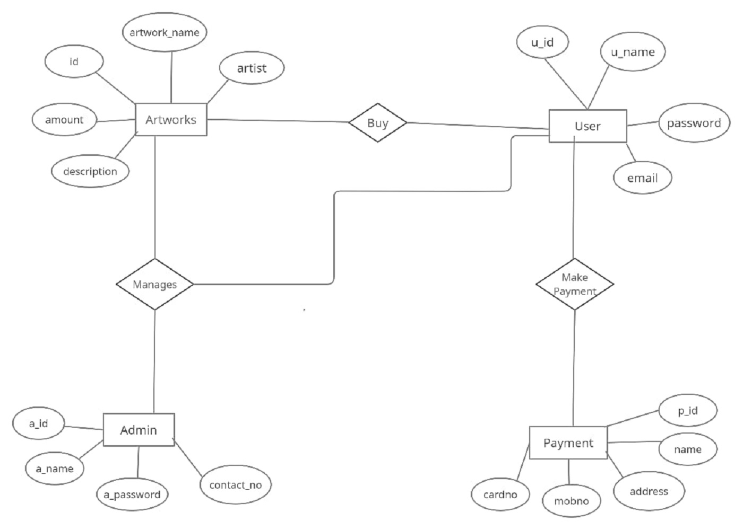

Use Case Diagram :

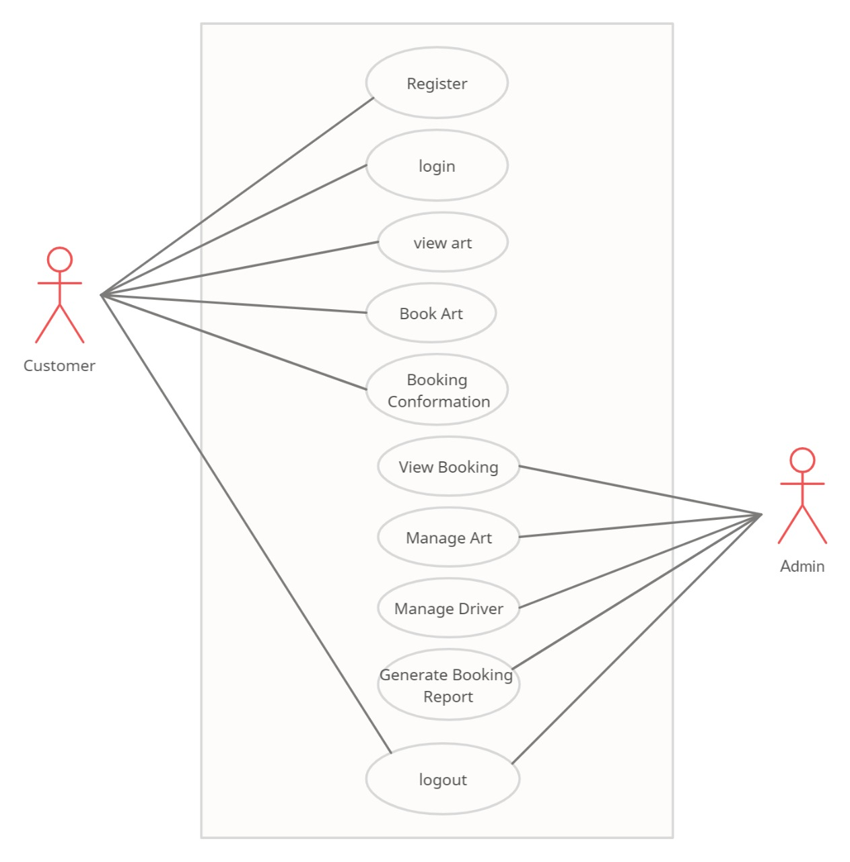

Collaboration Diagram :

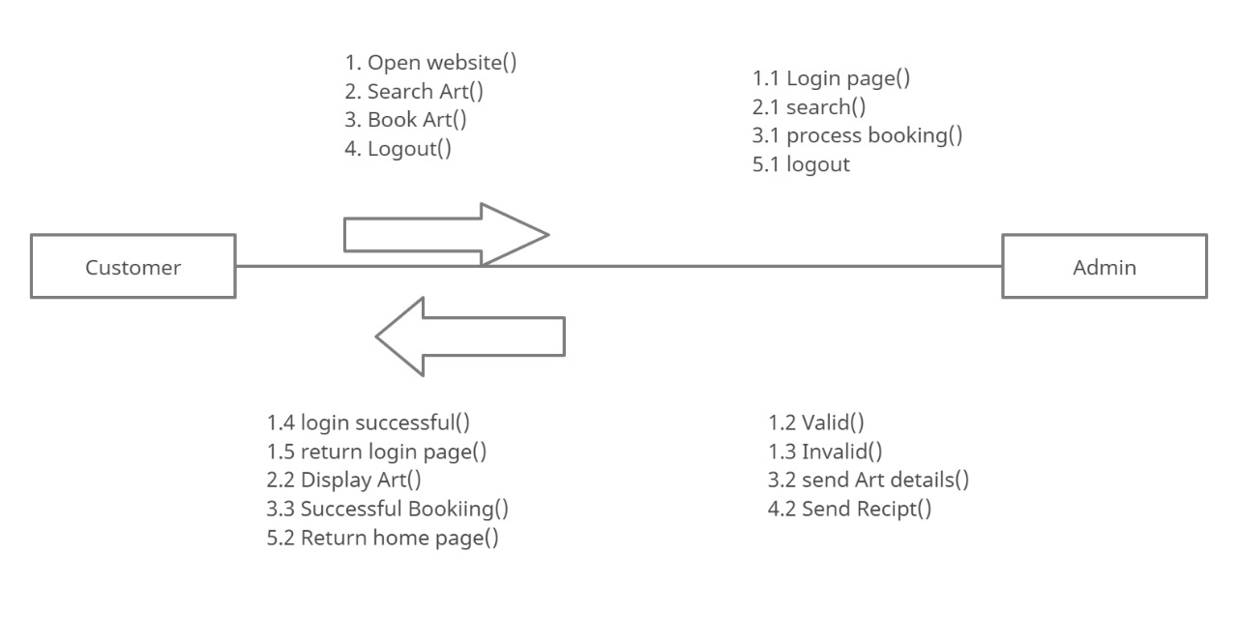

Activity Diagram :

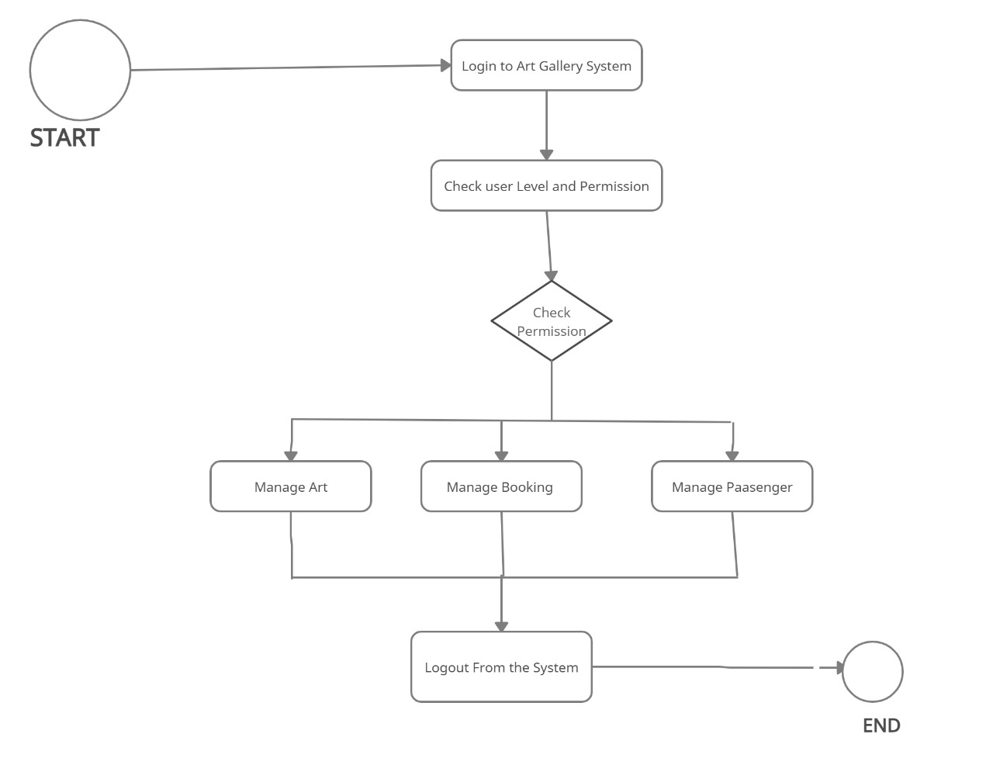

Sequence Diagram :

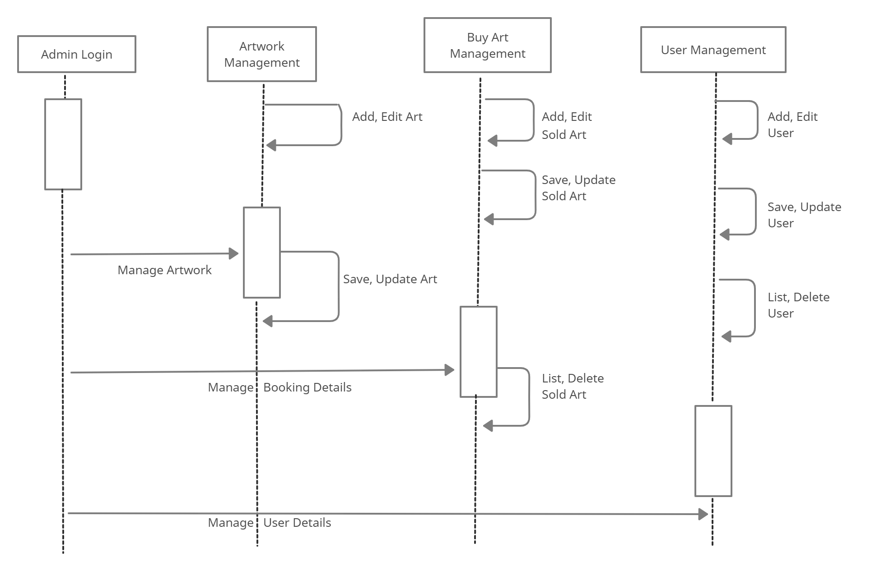

Component Diagram :

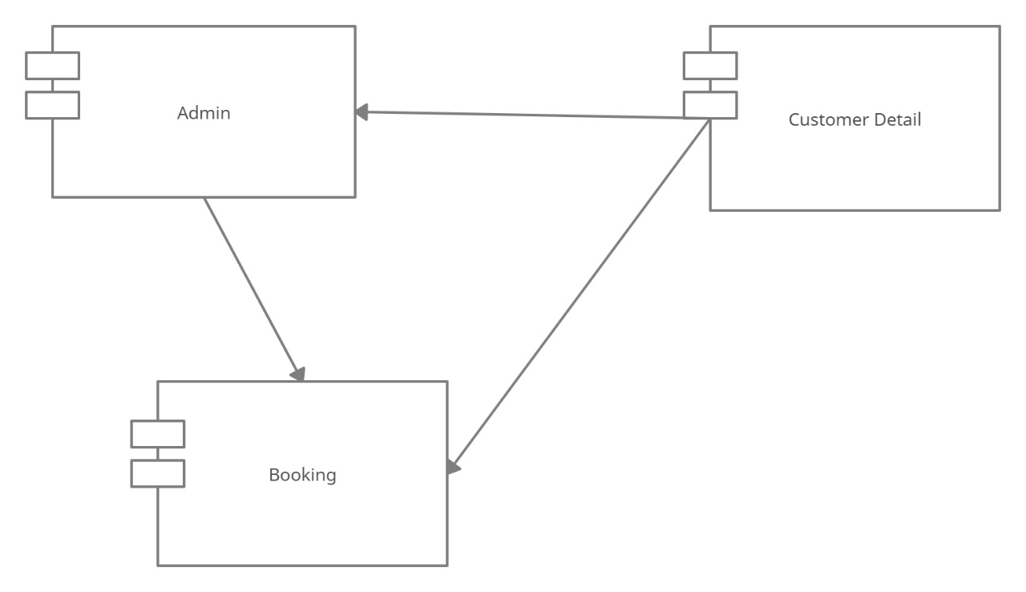

Deployment Diagram :

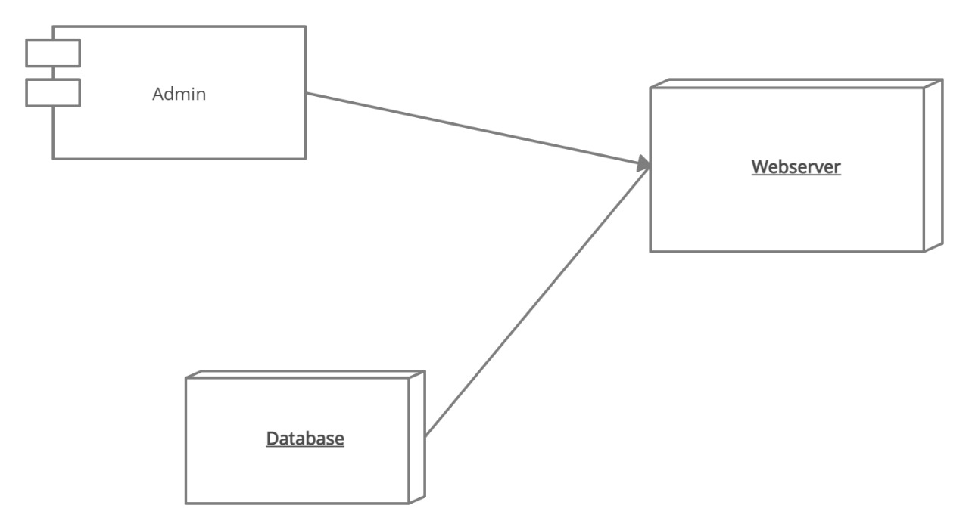

Class Diagram :

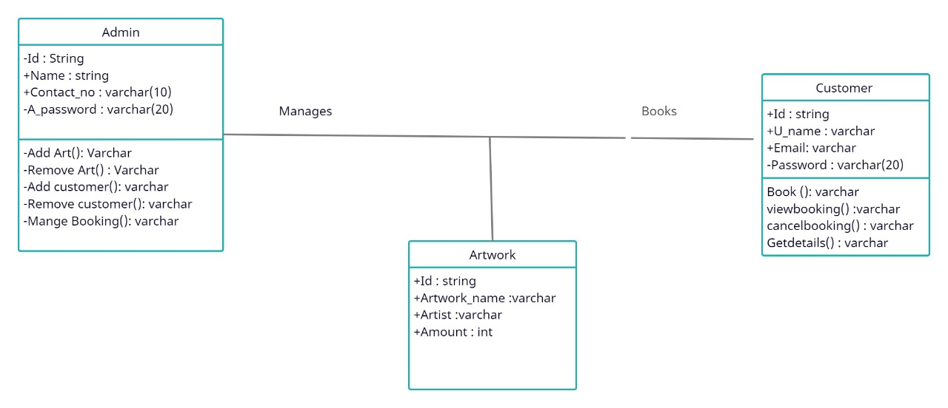

State Chart Diagram :

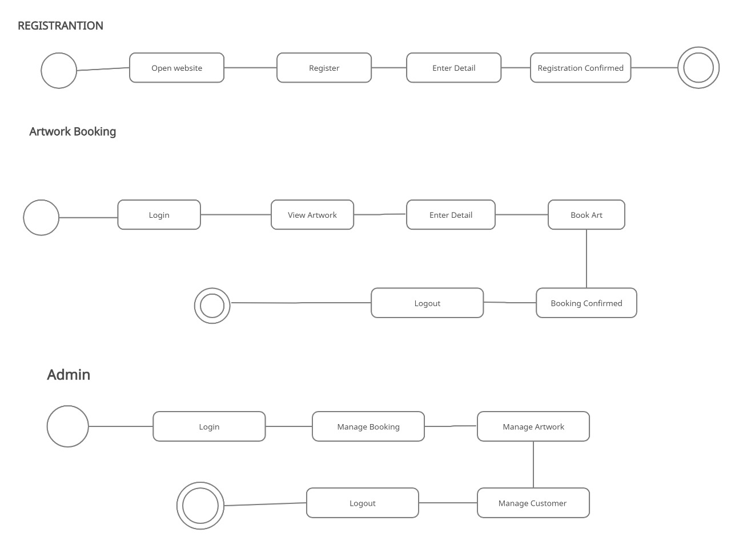

Data Dictionary Diagram :

1. Artworks –

|  |  |  |
| --- | --- | --- |
| ATTRIBUTE NAME | DATA TYPE | CONSTRAINT |
| Id | Int | Primary Key |
| artwork_name | Varchar |  |
| artist_name | Varchar |  |
| description | Varchar |  |
| amount | Int |  |

1. Payment –

|  |  |  |
| --- | --- | --- |
| ATTRIBUTE NAME | DATA TYPE | CONSTRAINT |
| pid | Int | Primary Key |
| full_name | Varchar |  |
| address | Varchar |  |
| mobno | Int |  |
| card_no | Int |  |

1. Users –

|  |  |  |
| --- | --- | --- |
| ATTRIBUTE NAME | DATA TYPE | CONSTRAINT |
| uid | Int | Primary Key |
| user | Varchar |  |
| pass | Varchar |  |
| email | Varchar |  |